VOLTRELAY ENERGY

DATA ANALYTICS & OPERATIONAL
PERFORMANCE ANALYSIS

Hackathon Analysis Report

Prepared By
Kunal Shukla
Data Analyst

26th September 2026

Gradient Learnings
Online Data Analytics Hackathon 2026

1. Executive Summary
This report presents the analysis of VoltRelay Energy's simulated battery-swapping network. The dataset covers swap activity from January 2024 to June 2025 across six Indian cities.
There were 3,877,013 swap events in the dataset. 3,645,809 were completed successfully and 231,204 were non-completed. The overall non-completion rate was 5.96%.
Completed swaps generated about ₹23.31 crore in revenue, with average revenue of ₹63.94 per completed swap. The analysis mainly focused on failures, queues, cities, stations, batteries, customer support and rider activity.

2. Business Problem
The main objective was to understand why some swap attempts were not completed and where operational problems were more visible. The analysis also looked at changes over time and differences between cities and stations.
The main questions were related to network performance, service failures, station performance, battery health, pricing and rider experience.

3. Data and Tools Used
The hackathon provided eight CSV files containing information about swap events, stations, riders, batteries, support tickets, station status, city context and fleet partners.
Tools used:
- Python
- Pandas
- Matplotlib
- Google Colab
- MS Word for the final report

4. Data Cleaning
Before analysis, I checked the data for missing values, duplicate records and unusual values.
The km_since_last_swap column contained negative and unusually high values. A cleaned version was created using a reasonable range of 0 to 150 km.
Some SOC and SOH values were above 100, so cleaned versions were created for analysis. Missing telemetry values were kept as missing instead of treating them as zero.
The dataset documentation also mentioned timestamp and other data-quality issues, so these were considered while interpreting the results.

5. Network Performance
The network recorded 3,877,013 total events and 3,645,809 completed swaps. The overall non-completion rate was 5.96%.
Metric | Value
Total events | 3,877,013
Completed swaps | 3,645,809
Non-completed events | 231,204
Failure / non-completion rate | 5.96%
Revenue from completed swaps | ₹23.31 crore
Average revenue per completed swap | ₹63.94

Monthly performance showed higher failure rates during some periods, especially May-June 2024 and April-June 2025.
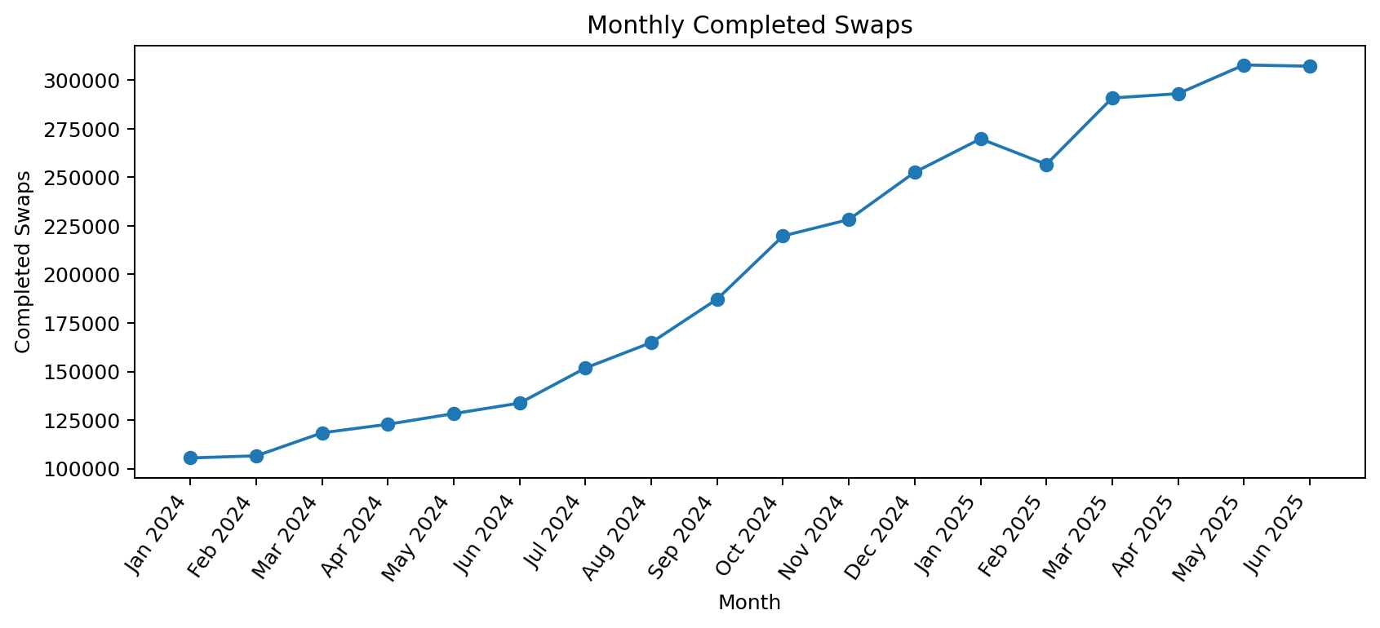
Figure 1: Monthly Completed Swaps
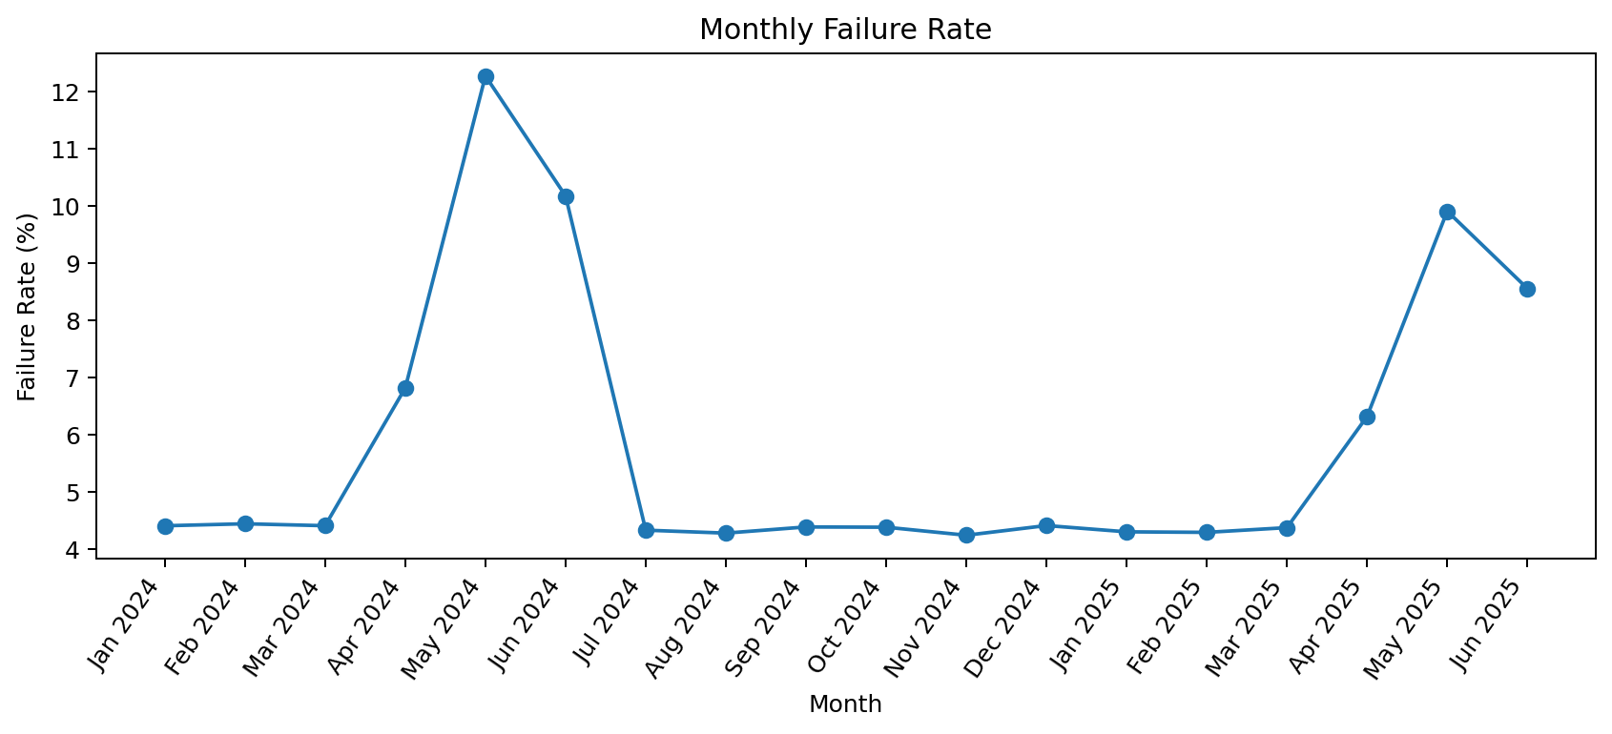
Figure 2: Monthly Failure Rate

6. Service Failure Analysis
The largest failure category was 'Failed - No Charged Battery'. It represented 58.13% of all non-completed events. Abandoned Queue represented another 29.64%.
Together, these two categories represented 87.77% of non-completed events. This suggests that battery availability and queue management are important areas to investigate.
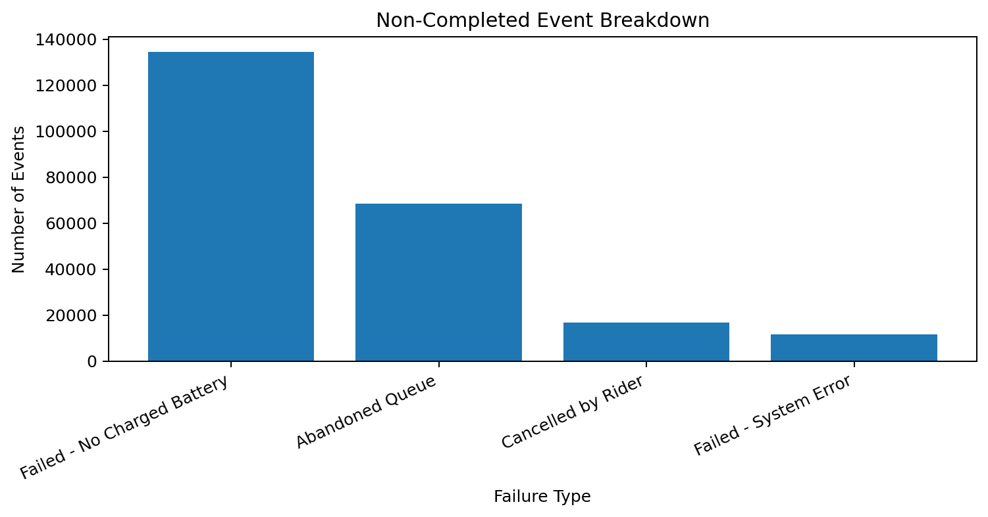
Figure 3: Failure Reason Breakdown

7. City-wise Analysis
Failure rates were different across the six cities. Jaipur had an observed failure rate of 7.85%, followed by Delhi NCR at 7.35% and Hyderabad at 6.69%. Pune was 4.99%, Bengaluru was 4.56% and Mumbai was 4.45%.
City | Failure Rate
Jaipur | 7.85%
Delhi NCR | 7.35%
Hyderabad | 6.69%
Pune | 4.99%
Bengaluru | 4.56%
Mumbai | 4.45%
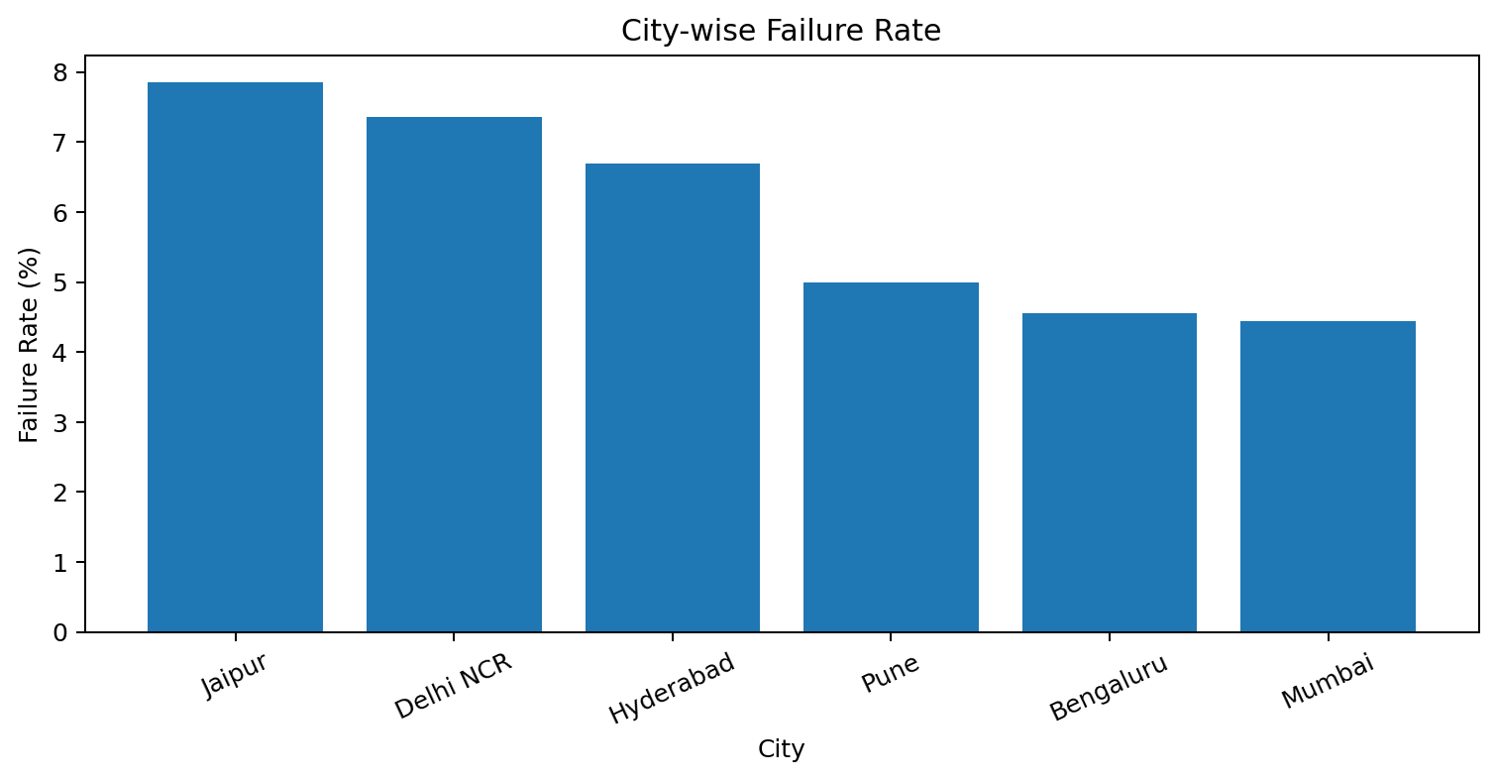
Figure 4: City-wise Failure Rate

8. Battery and Equipment Analysis
Battery data was checked using supplier, manufacturing lot, battery age and state-of-health information. The purpose was to identify patterns that could be useful for further operational investigation.
The results should be treated as associations because the analysis is based on observational data and does not prove that a particular battery supplier or equipment characteristic caused a failure.

9. Customer Support Analysis
Support tickets were analysed using ticket category, priority, resolution status, resolution time and CSAT score. City and station complaint patterns were also examined.
This helped provide a customer-experience view alongside the operational failure analysis.

10. Pricing and Rider Analysis
Pricing was examined using tariff codes and completed-swap revenue. Rider activity was also grouped to understand repeat completed-swap behaviour.
For the analysis, a rider with more than one completed swap was treated as having repeat activity. This is an operational definition used for this analysis and is not a formal long-term retention measure.

11. Key Findings
- The network recorded 3.88 million events with 3.65 million completed swaps.
- The overall non-completion rate was 5.96%.
- Failed - No Charged Battery was the largest non-completion category at 58.13%.
- Abandoned Queue represented 29.64% of non-completed events.
- Battery availability and queue abandonment together represented 87.77% of non-completed events.
- Failure rates increased during May-June 2024 and again during April-June 2025.
- Failure rates varied across cities, with Jaipur and Delhi NCR showing higher observed rates than Mumbai and Bengaluru.

12. Recommendations
- Monitor charged-battery availability at stations with high failure rates.
- Identify stations and hours with high queue abandonment and improve service capacity during those periods.
- Investigate high-failure stations using battery availability, queue time and customer complaints.
- Use historical monthly patterns to prepare additional operational capacity during higher-risk periods.
- Create a simple station-level dashboard containing failure rate, queue wait, battery availability and complaints.

13. Limitations
- The dataset is synthetic.
- The analysis shows patterns and associations and does not prove causation.
- Some telemetry values were missing or outside expected ranges.
- The dataset contains documented timestamp and other quality issues.
- The rider repeat-activity definition used here is only an operational proxy.

14. Conclusion
Overall, the analysis shows that battery availability, queue abandonment, monthly failure spikes and differences between cities are important areas for operational attention. A station-level monitoring approach can help identify problems earlier and support better planning of batteries and service capacity.

Appendix: Google Colab Notebook
Notebook link: https://colab.research.google.com/drive/1woIYijN2_pVsiGlMqcDBd3xdBEJzF9qJ?usp=sharing

AI Assistance & Tools Used
AI Assistance: ChatGPT was used during the project for technical support and content-related tasks. It helped me troubleshoot coding errors, understand and resolve issues while working in Google notebook , improve the structure and wording of the analysis, and prepare LinkedIn post content.

